# Square Brackets (1)

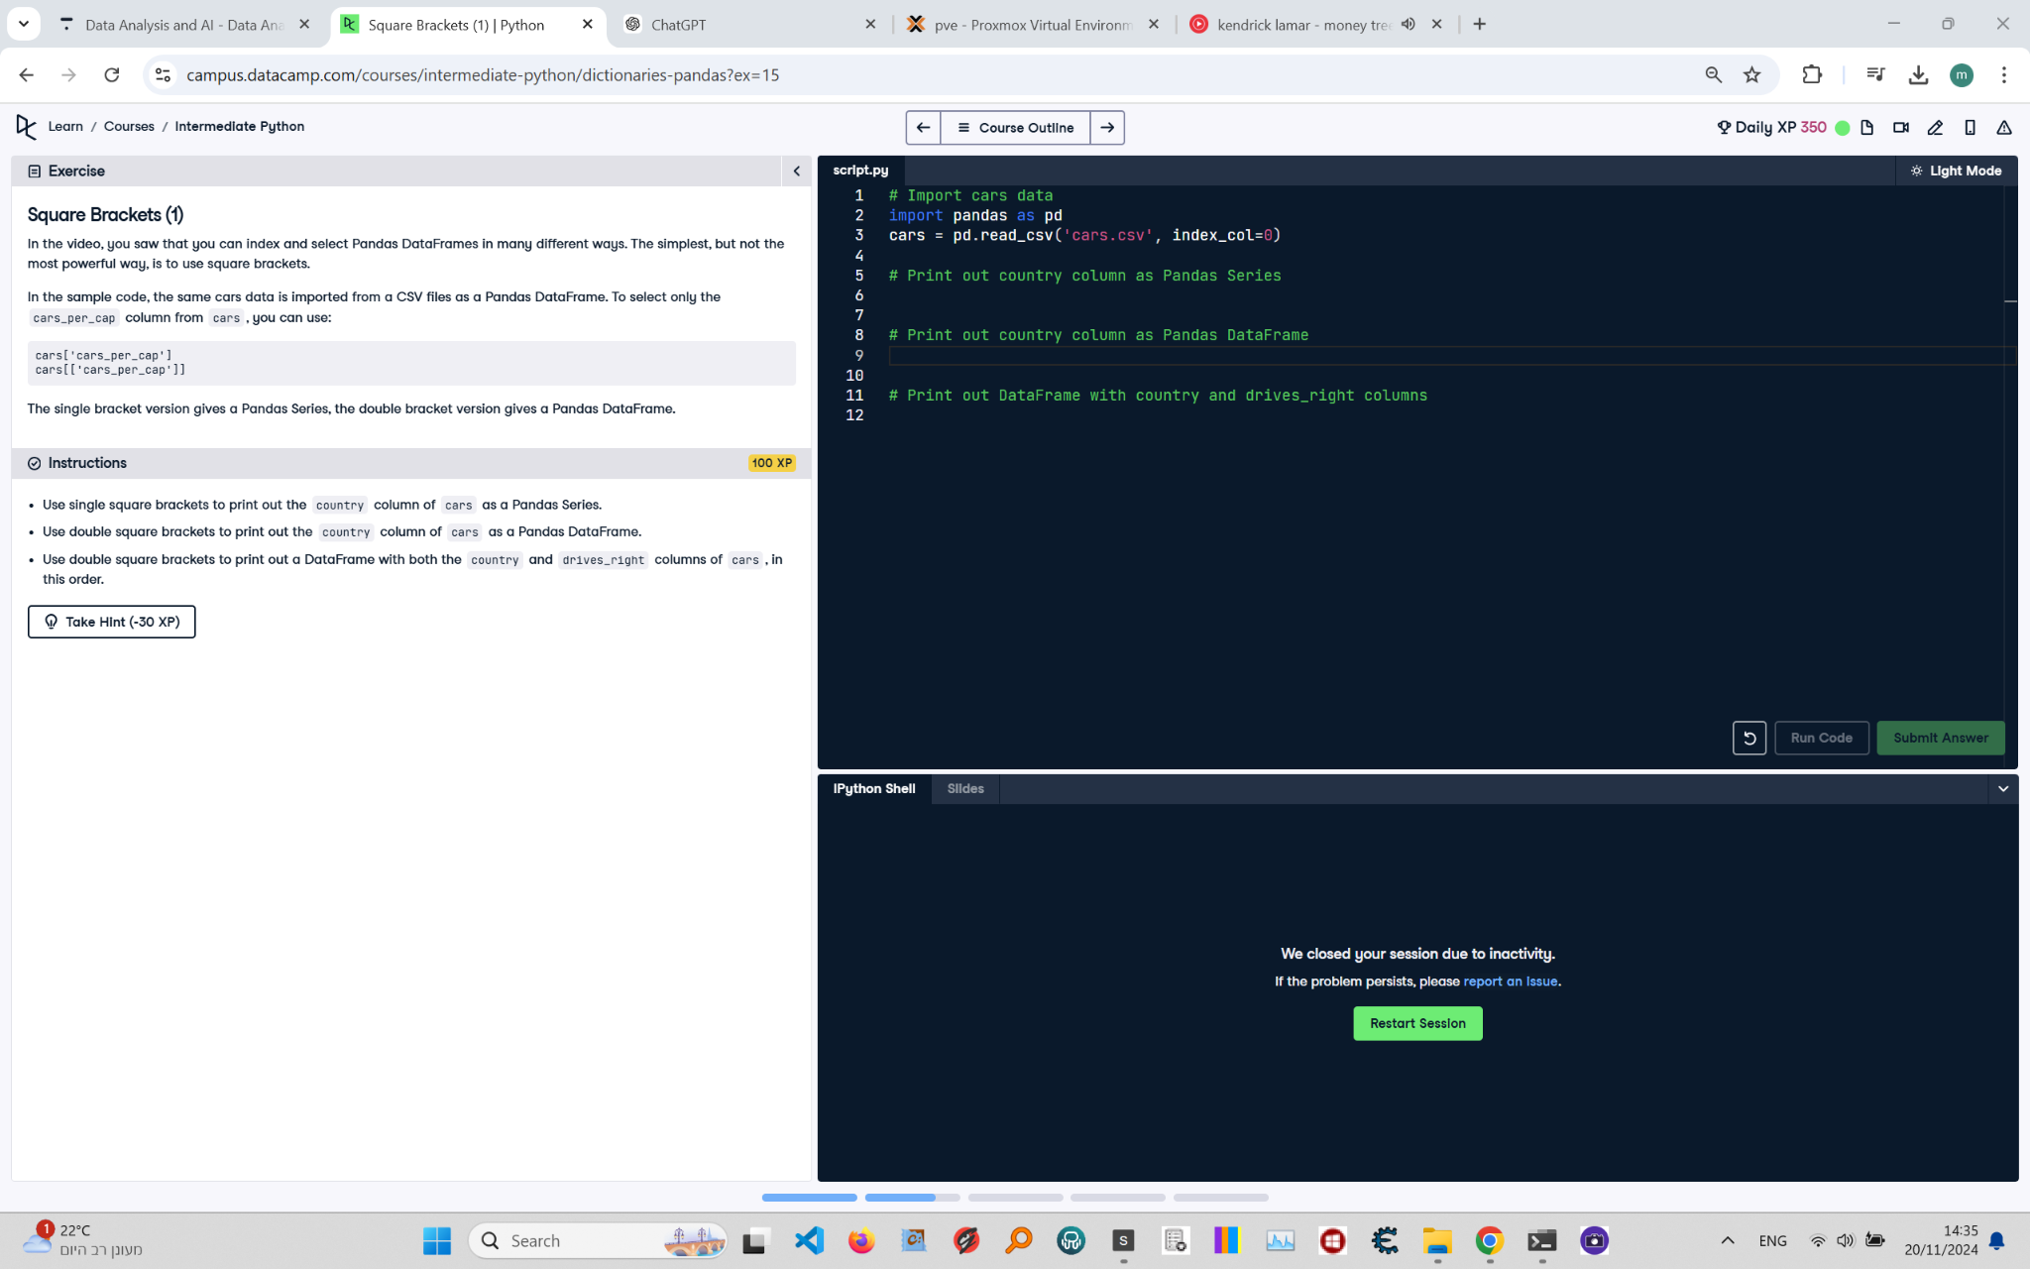

## Instructions:

1. Use single square brackets to print out the 'country' column of cars as a Pandas Series.  
2. Use double square brackets to print out the 'country' column of cars as a Pandas DataFrame.  
3. Use double square brackets to print out a DataFrame with both the 'country' and 'drives_right' columns of cars, in this order.

## Code and Explanation:

# Import cars data  
import pandas as pd  
cars = pd.read_csv('cars.csv', index_col=0)  
  
# Print out country column as Pandas Series  
print(cars['country'])  
  
# Print out country column as Pandas DataFrame  
print(cars[['country']])  
  
# Print out DataFrame with country and drives_right columns  
print(cars[['country', 'drives_right']])

Explanation of the Code:  
1. The 'cars.csv' file is read into a Pandas DataFrame using pd.read_csv with index_col=0 to set the first column as the index.  
2. The single square brackets 'cars['country']' extract the 'country' column as a Pandas Series.  
3. Double square brackets 'cars[['country']]' extract the 'country' column as a Pandas DataFrame.  
4. Double square brackets 'cars[['country', 'drives_right']]' extract the 'country' and 'drives_right' columns as a new DataFrame.